MACH4METAL

Metalworking machinery
Transito 21,
6909 DA BABBERICH
Netherlands
Tel. +31 (0)316 – 247123
Fax. +31 (0)316 - 247956
info@mach4metal.com
www.mach4metal.com

Account No: 66.52.13.883
IBAN : NL33 INGB 0665 2138 83
BIC : INGBNL2A

Bed milling machine Ki HEUNG

- Make : KI HEUNG Korea
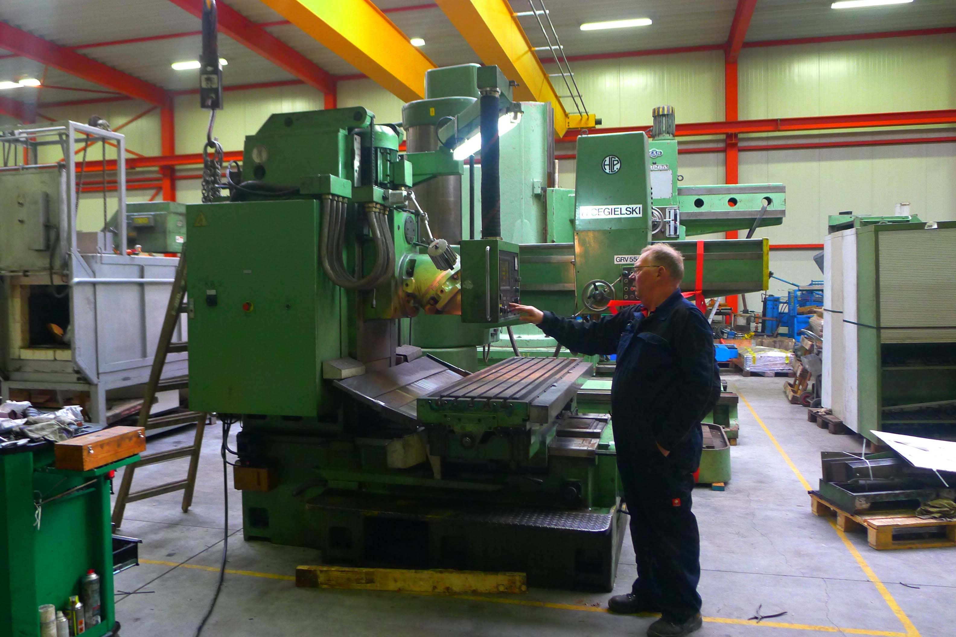
- Typ : KMB U 6
- Age : 1996
- No. : 6011 502

- Table dimensions
- Length : 2.200
- Width : 550
- Work piece Load : 3.000

- Movements – Travels
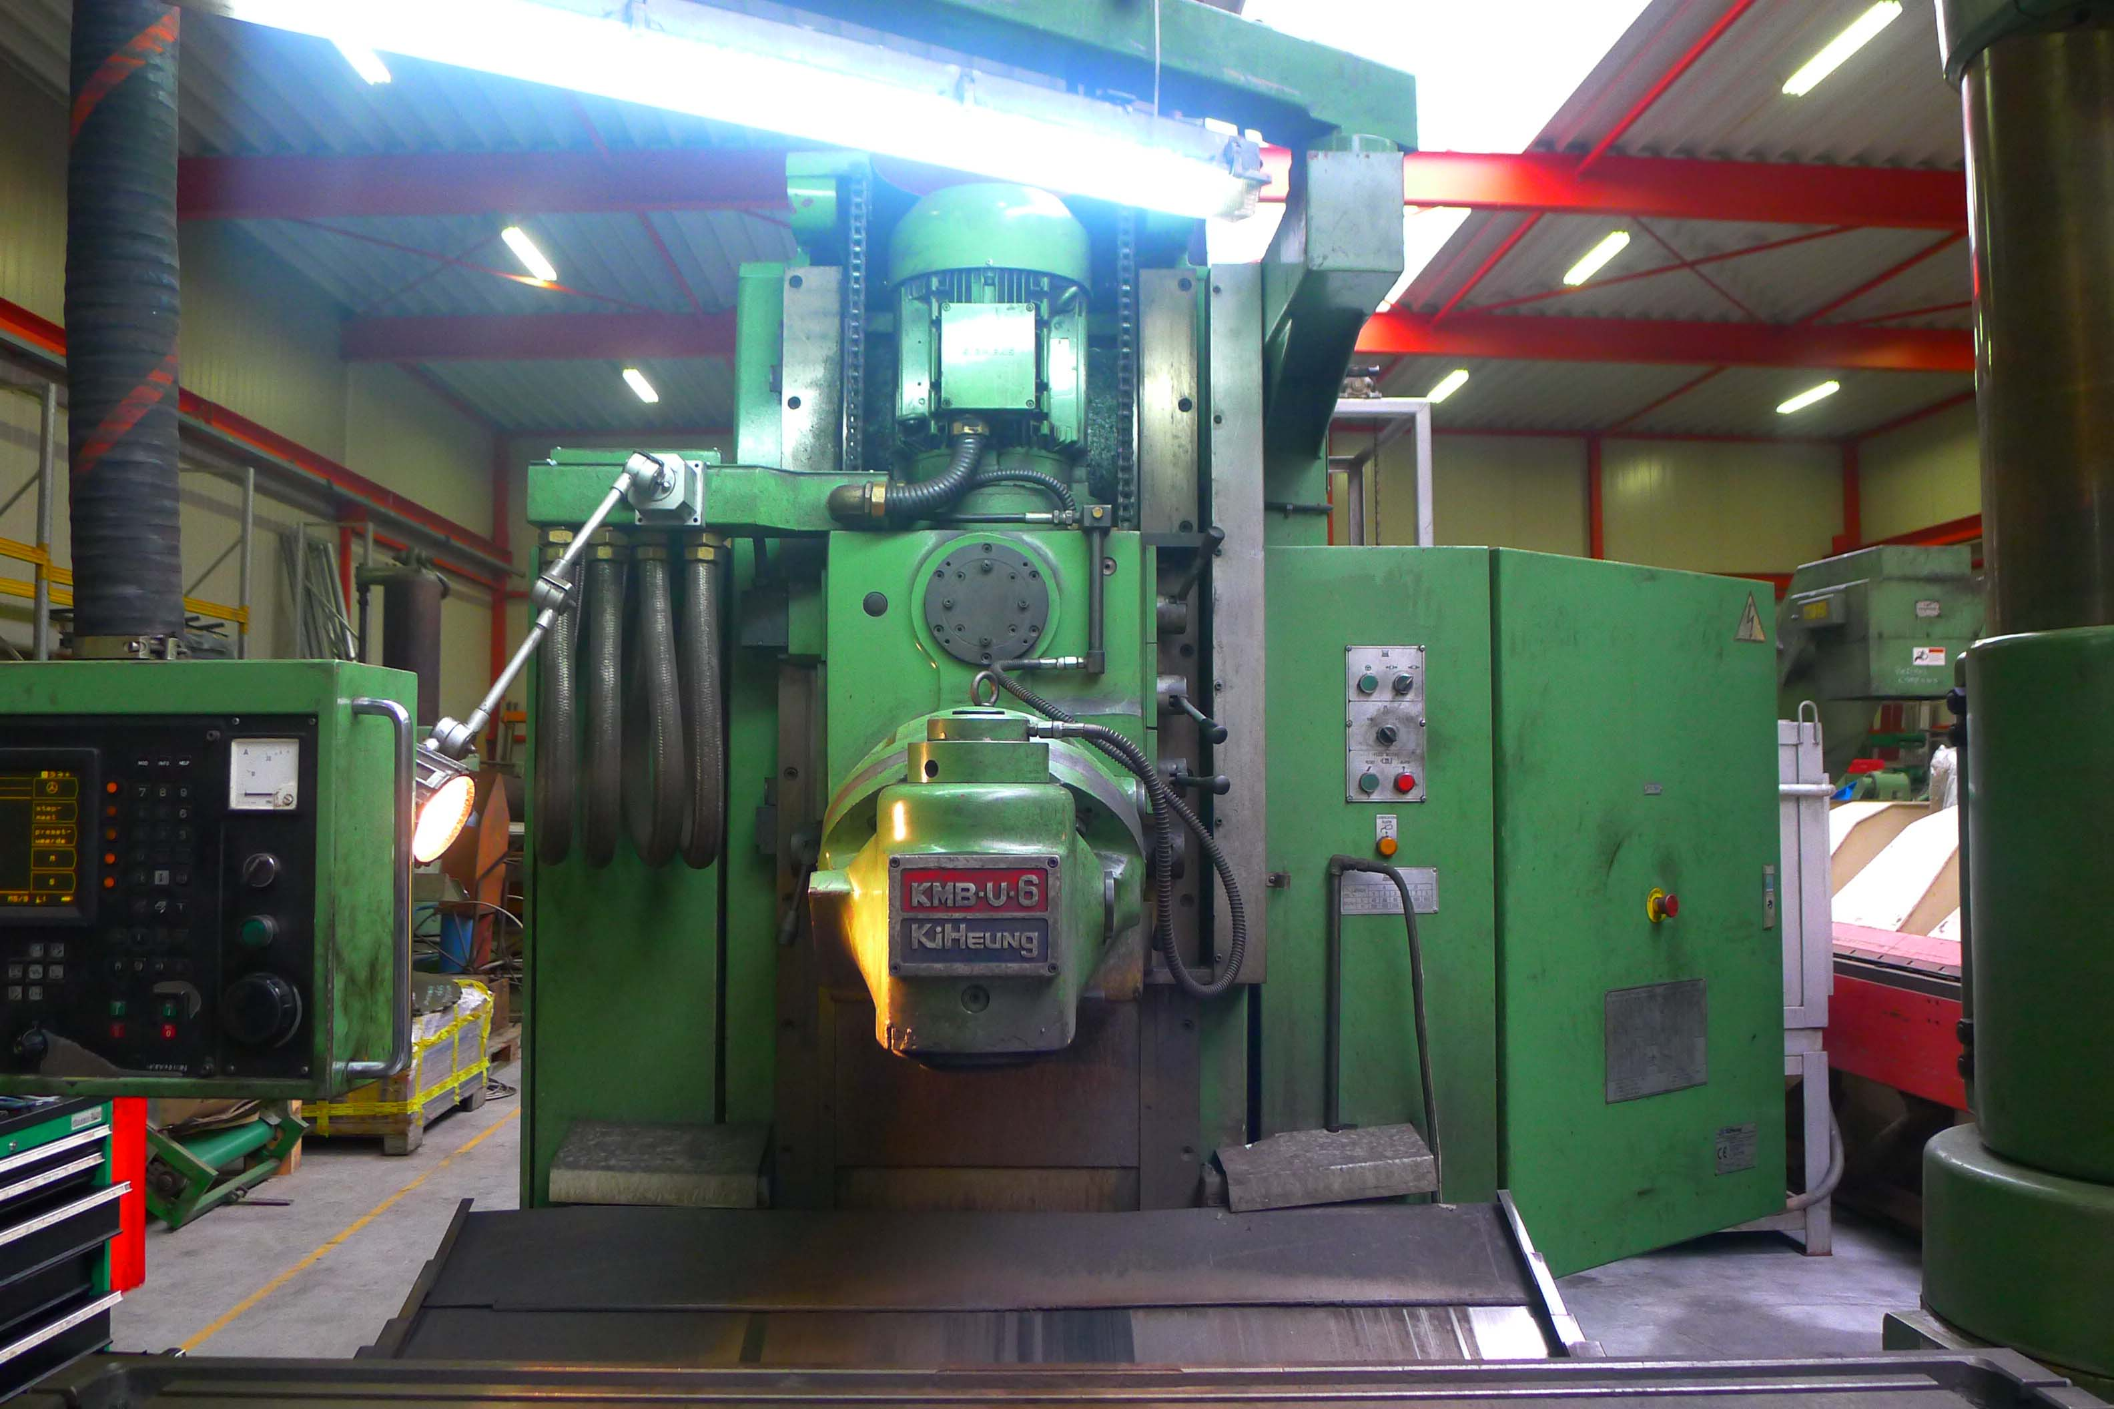
- X : 1.600
- Y : 720
- Z : 750

- Spindle : 50 Iso
- Speeds : 40 – 1.600 Rpm
- Milling head power : 11 kW

- Feeding range : 0.01 – 2.000 rpm
- Rapid traverse : 0.01 – 3.200 rpm
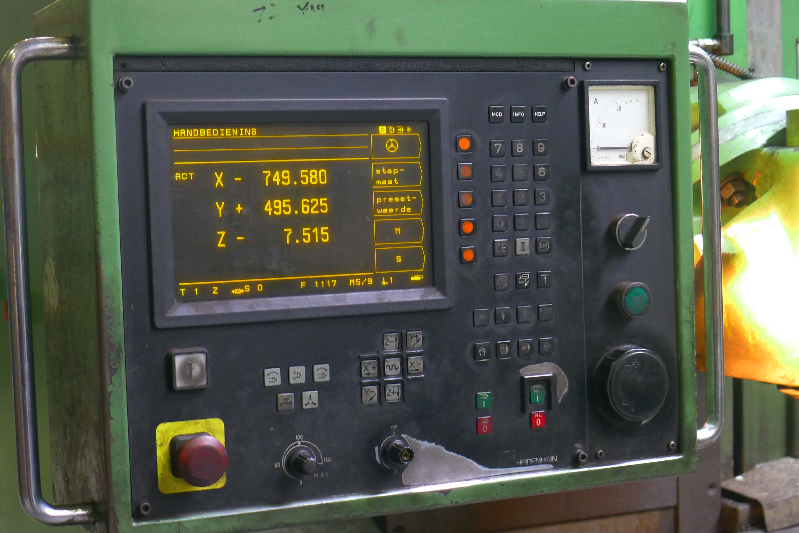

- Universal milling head
- Dr. HeidenHain 3 axis dro
- Hydraulic tool clamping
- 2 Doors on front side

- Dimensions : 4.760 / 2.720 / 3.050
- Weight : 8.000 Kg

Please Note: The above information has been obtained to the best of our ability and belief from, and from the manufacturers where possible. It is given in good faith, but its accuracy can not be guaranteed. Accordingly, it will not form a representation or constitute contr actual terms. We advise you to check any vital details!

